MDSE 3250 Concept to Production: The Design Spec
Date:2/21/20
Points Possible: 20
Name(s): Jennifer Sweatman, Michelle Olvera, Allison C Dibble, Clarissa Navarrete
Objectives of the Lab:
- Using the Aspirational Brand, identify the garment you will knock-off (Designer RTW).
- Comp Shopping: research the garment you will knock-off to determine if it is suitable. If not find another.
- Create a Design spec sheet for the garment as it is on the website.
- Identify basic pattern pieces and features of the garment to be knocked-off; create cost sheet for as it is on the website.
Spec Sheets (Final Project Group—set up as a group assignment): Create the following design specification sheets for the knock-off garment (as it is online—do not alter the design of the garment in any way). Complete the exercise with your Final Project Group online and upload before the end of class. Remember that the information gathered in these common design spec sheets is most often used to determine whether to continue to develop the style or to reject the style. Use the provided forms below.
      - Copy and paste the website of the garment you will knock-off here: 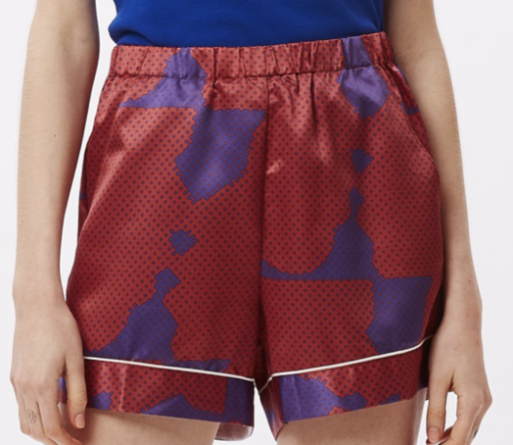
https://obeyclothing.com/products/obey-makeout-short?variant=31483268005949

      - Comp Shopping: go to a mass merchandise website and a moderate price point. Is the garment available there? Why would we care? Do you need to find something newer, more interesting?
Information | Your Knock-off Garment  Obey | Budget or Mass Merch  Walmart | Moderate  Nike
Retail Price/Sale Price | $60 | $11 | $20
Colors | Red and purple | Blue | Black
Fiber Content | 100% Polyester | 97% Polyester, 3% Spandex | 100% Polyester
Fabric Description if any | COMES IN A CUSTOM OBEY PRINT ON SHINY SATIN FABRIC |  | Dri-FIT moisture-wicking technology.
Copy on Website | https://obeyclothing.com/products/obey-makeout-short?variant=31483268005949 | https://us.romwe.com/Contrast-Binding-Satin-PJ-Set-p-475481-cat-1286.html | https://www.soccer.com/shop/details/nike-women-s-laser-iv-woven-short_A1021803
Other

      - Style Summary Sheet (Home Furnishings may modify to suit): use the following descriptions to fill out the design spec sheet. Spec the garment as it is on the website.
- Style#: 272120071
- Division: Women’s
- Size Category: Regular, Plus Size
- Size Range: xxs, xs, s, m, l, xl, xxl, xxl
- Sample Size: Leave this blank for now.
- Season: current
- Estimate: $11.96
- Description: sport shorts
- Merchandiser/Designer/Technical Designer: Jane Doe
- Brand: Obey
- Fabric: 100%, woven, satin
- Colors: red and blue, light blue and orange
- Create Date: 2/21/20
- Modified: leave blank…guess what this is for?
- Due Date: leave blank
- Ship Date: 3/1/21
- Vendor: woopity dooda
- Front and Back: 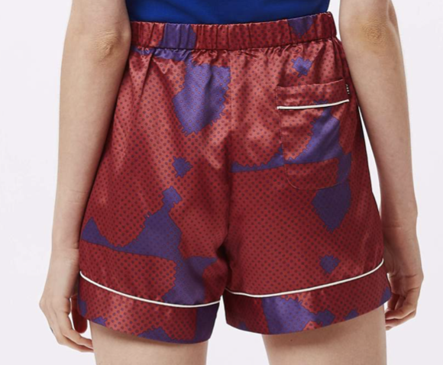
- Description: Elastic waist boxer short with contrast piping details, custom print on shiny satin fabric, RISE: 12 ; LEG OPENING: 25 ; INSEAM: 4 1/2
- Preliminary Cost Sheet: an estimate for ONE garment or product (Home Furnishings may modify to suit)
Note that certain information is repeated so that it is easy to match up pages if they are printed out. Enter the same information from the Style Summary Sheet. Here’s what’s different:
- Size: xxs, xs, s, m, l, xl, xxl, xxxl
- Size Set: http://www.createafashionbrand.com/garment-size-set/. Enter the sizes you want to see.
- Begin costing:
        - Fabrics: 1 yard per short, $2.24 for patterns , 1.90 for wholesale price per yard.
        - Findings and trims: Satin Sewing Trim - .80 cents
        - Labels: care label = $0.04; brand label = $0.16; hang tag/price ticket = $1.57; packaging = $0.24
        - Cutting =$2
        - Labor (Sewing or other assembly) = $4
        - Shipping: $1.25
        - Duty = 16% of labor + materials- $5.35
        - Overhead = 18% of labor + materials- $5.43

Answer the remaining questions using your estimates. At this point, buyers and PD decide whether the item can be made within the Line Plan to meet the buyer’s goals. The goal was to see how close you could come to the online price of your knockoff product.

STYLE SUMMARY SHEET
FRONT | BACK

Style#: 272120071 | Description: Sport Shorts | Create Date: 2/21/20
Division: Women’s | Merchandiser: jane doe | Modified: n/a
Size Category: regular, plus size | Designer: jane doe | Due Date: n/a
Size Range: xxs, xs, s, m, l, xl, xxl, xxxl | Technical Designer: jane doe | Ship Date: 3/1/2021
Sample Size: | Brand: Obey | Vendor: woopity dooda
Season: current | Fabric: polyester (satin)
Estimate: $11.96 | Colors: purple

DESCRIPTION: Elastic waist boxer short with contrast piping details, custom print on shiny satin fabric, RISE: 12 ; LEG OPENING: 25 ; INSEAM: 4 1/2

PRELIMINARY COST SHEET
COST SHEET | Style#: 272120071 | Description: Sport Short | Date:2/21/20
COST SHEET | Division: Women’s | Size Category: Regular, plus | Season: current
COST SHEET | Sample Size: n/a | Tech Designer: jane doe | Color: purple
COST SHEET | Fabric: polyester (satin)

SIZE | XXS | XS | S | M | L | XL | XXL | XXXL
SIZE SET

FABRIC | YARDAGE | PRICE | COST
Satin | 1 yard | $1.90 | $1.90
Patterns | n/a | $2.40 | 2.40
TOTAL FABRIC COST |  |  | $4.30

TRIM/FINDINGS | QUANTITY | PRICE | COST
Satin Sewing Trim | 1 yard | .80 cents | .80 cents
TOTAL TRIM COST |  |  | 80 cents

LABOR | COST
CUTTING | $2
SEWING | $4
TOTAL LABOR | $6

MISC. | DESCRIPTION | COST
SHIPPING | $15 per dozen | $1.25
DUTY | 16% of labor + materials | $5.35
OVERHEAD | 18% of labor + materials | $5.43

TOTAL COST (materials + labor + misc.) = | $23.13
WHOLESALE MARKUP (50% of total cost) = | $11.56
WHOLESALE PRICE (total cost + wholesale markup) = | $34.69
What was the retail price of the original garment? | $60
- How close did you come to the actual retail price of the garment you selected? Why do you think you did or did not come close? I would say that we did not come close enough, but the garment we chose is also a bit overpriced because of the name. I think that Obey probably sells their product for double the price that they make it for.

- What will you do to knock-off this garment and achieve something your target customer will buy and be able to afford? We will use a cheaper polyester to create a cheaper satin, as well as making less claims on the garment, as it is not actually used for active wear, just fashion. We will make a smaller profit off each garment as well, to make the product cheaper for our consumers.

